Name:- Valle Ramesh

- Model comparison table :-
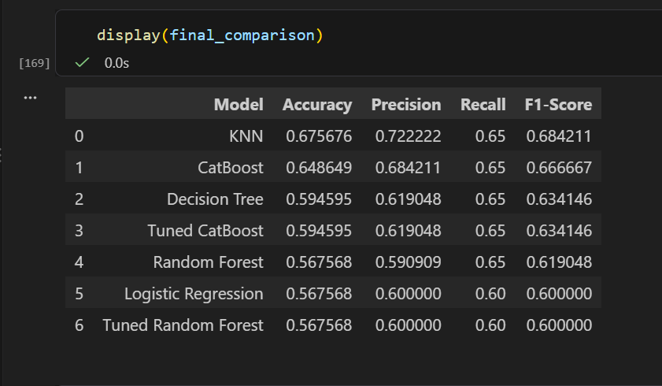

- ) Confusion matrix for the selected model :-
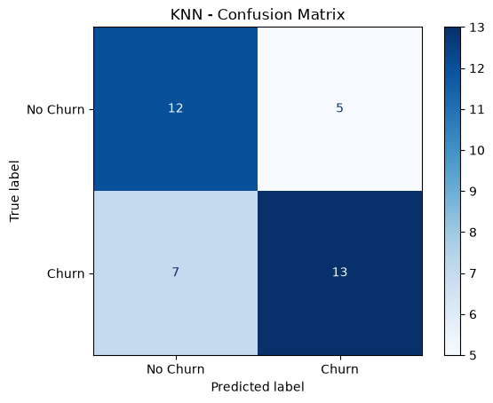

5.) 3–5 business insights :-
1. Customer retention: Use the KNN model to identify customers at risk of churn and prioritize personalized retention campaigns.
2. Customer behavior: Analyze customer segments and top permutation-importance features to understand characteristics associated with churn.
3. Missed churners: Reduce false negatives by improving recall, helping the retention team identify more actual churners.
4. Retention costs: Manage false positives by prioritizing customers based on customer value and campaign cost.
5. Model improvement: Collect more customer data, including complaints, payment history, and service usage, to improve prediction reliability.

6. Conclusion:-
The KNN model achieved the highest test accuracy of 67.57% and an F1-score of 68.42% among the evaluated models. It can support customer retention by identifying potentially at-risk customers. However, the small dataset and limited test sample restrict generalization. Further validation using larger datasets and continuous performance monitoring is required before real-world deployment.

